Initial GUI:

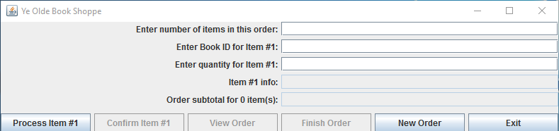

Initial input:

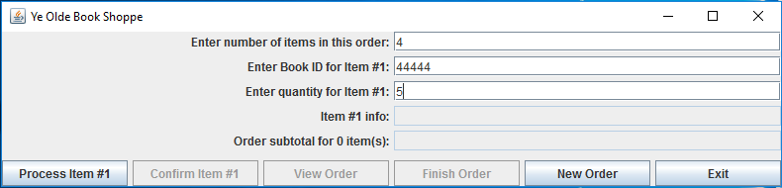

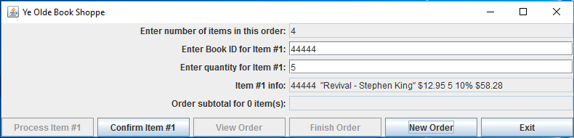

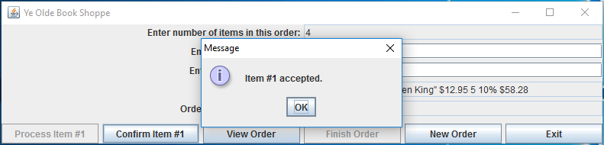

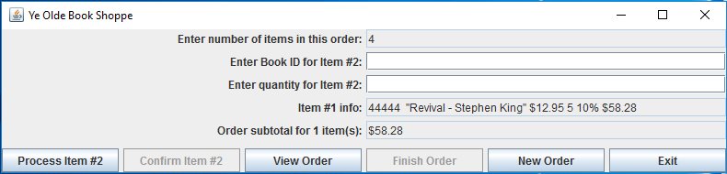

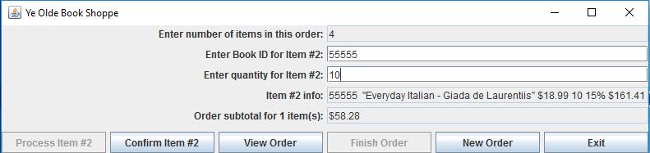

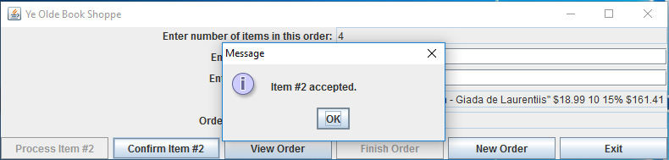

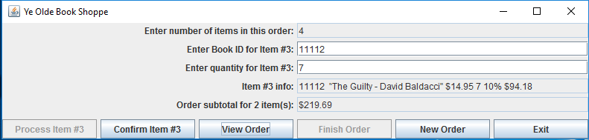

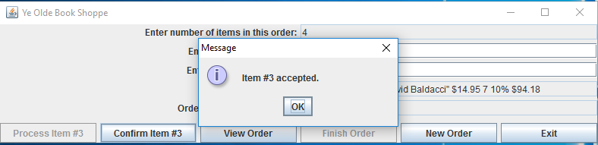

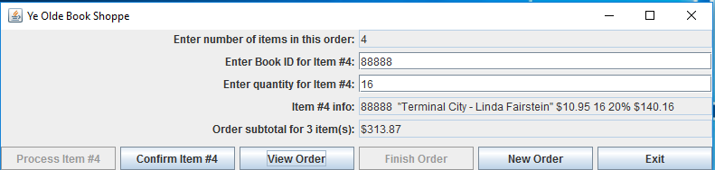

Viewing order at current point in time:

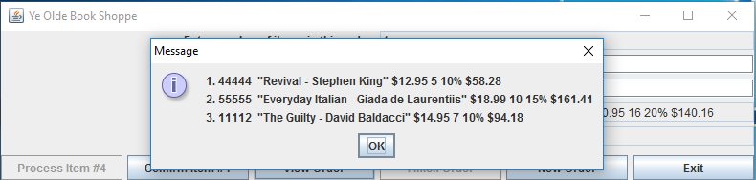

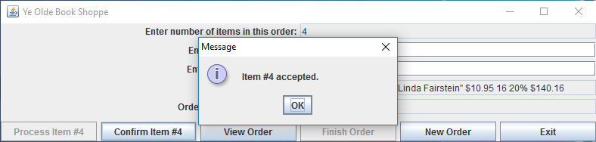

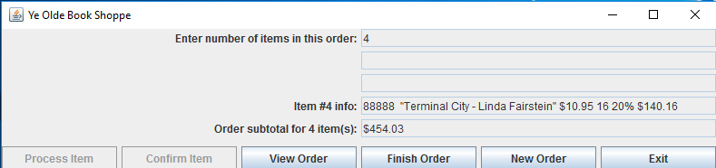

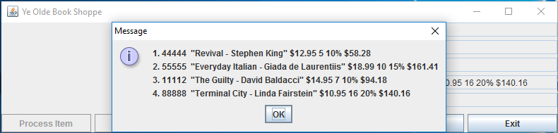

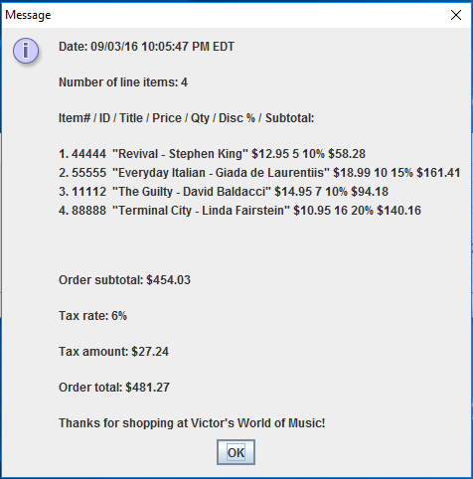

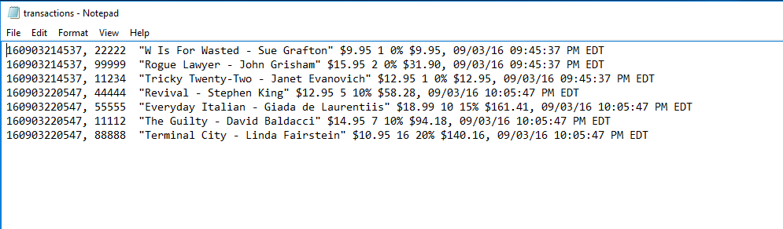

Incorrect book ID:

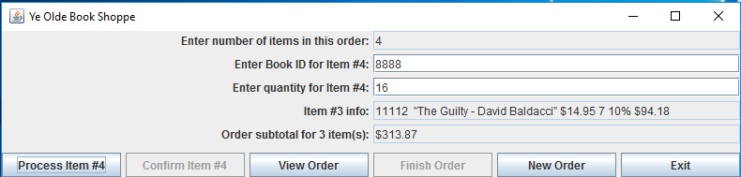

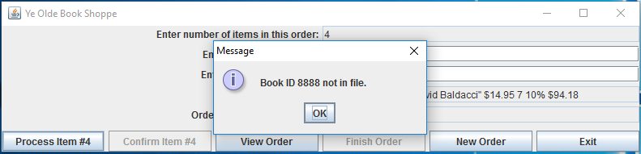

New order:

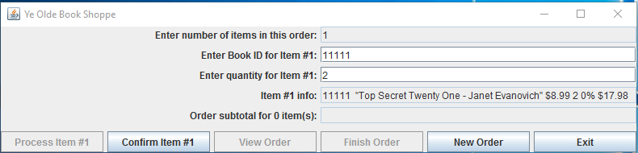

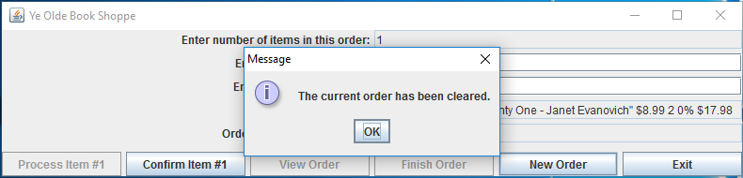

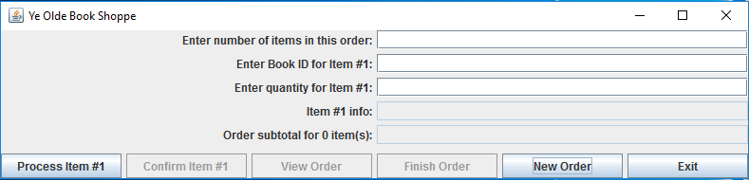

Also, the finish order button resets the program after writing to the transaction log, setting it up for a new order.